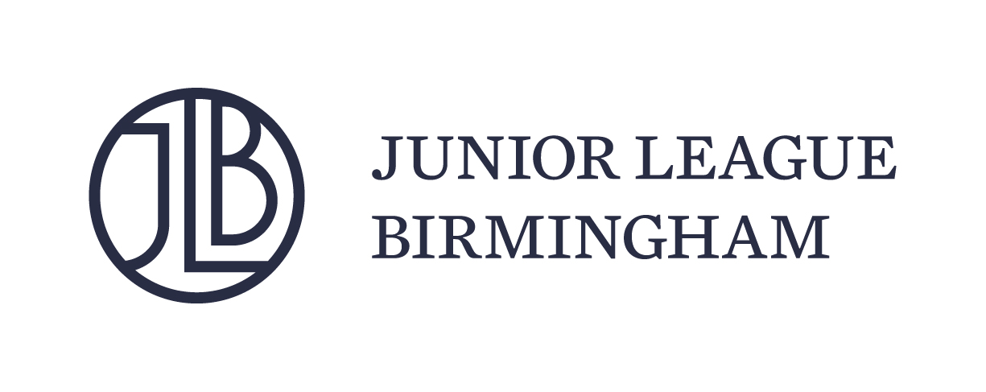

NEWSHEET ADVERTISING CONTRACT
Magazine of the Junior League of Birmingham, Inc.
2212 Twentieth Avenue So. • Birmingham, AL 35223
Phone: (205) 879-9861 • Fax: (205) 879-9868

Advertiser: ______________________________________________________________________ Phone: ______________________

Mailing Address: _______________________________________ City/State: ______________________________ Zip: ___________

Billing Address: ________________________________________ City/State: ______________________________ Zip: ___________

Contact Person: ____________________________ Ad Agency: ____________________________ Phone: ______________________

Email Address: ____________________________________________

We wish to advertise in NEWSHEET for the issues marked below. We understand that NEWSHEET must have our ad by the appropriate deadline or it will not be printed. Advertisers who sign a 2-issue contract are responsible for submitting an updated ad by the appropriate deadline. If a new ad copy is not received by the deadline, NEWSHEET reserves the right to print our previous ad.

ISSUE | CONTRACT DEADLINE | ARTWORK DEADLINE | PUBLICATION DATE
☐ Fall | August 15, 2018 | August 22, 2018 | October 2018
☐ Spring | February 20, 2019 | February 27, 2019 | April 2019
Would you like to run the same ad for both issues? ☐ Yes ☐ No ☐ Possibly – please follow up

CAMERA-READY ARTWORK IS REQUIRED FOR PRINTING. Advertisers should provide camera-ready artwork by the ad deadline to: adsales@jlbonline.com or 2212 Twentieth Avenue South, Birmingham, AL 35223. Acceptable formats are: PDF, JPEG, TIFF, EPS, and Quark XPress 4.0 or 5.0. When sending EPS or Quark files, include all artwork and fonts. SHOULD TYPESETTING BE REQUIRED, A $40/HOUR CHARGE WILL BE ADDED TO YOUR BILL.

COLOR | 1 ISSUE | 2 ISSUES (includes a 15% discount; must be paid in full.)
☐ NEW! Full Color 2-Page Spread | $1,350 | $2,295
☐ Premium Placement Full Page Bleed  (8-3/4” x 11-1/4”) | $800 | $1,600
☐ Full Page Bleed (8-3/4” x 11-1/4”) | $700 | $1,190
☐ Full Page Non-Bleed (7-1/2” x 10”) | $700 | $1,190
☐ 1/2 Page Horizontal (7-1/2” x 5”) | $500 | $850
☐ 1/2 Page Vertical (3-3/4” x 10”) | $500 | $850
☐ 1/4 Page (3-3/4” x 5”) | $350 | $595

1. All advertising charges will be invoiced on the publication date and are payable within thirty (30) days of invoice. If payment is not made by due date,
NEWSHEET reserves the right to cancel any reservation made by advertiser for space in subsequent issues.
2. A service charge of 1-1/2% of the unpaid balance will be added each month to all amounts not paid within thirty (30) days of invoice date.
3. If an advertiser’s account is delinquent and placed with an attorney or collection agency, the advertiser agrees to pay all costs of collection, together with accrued interest, plus court costs and a reasonable attorney’s fee.
4. Neither the Junior League of Birmingham, Inc. nor any of its members, agents, or employees will be responsible for any losses, liability or damage sustained, due to errors in advertisements, content of advertisements or for any other claims, but will be liable for the actual cost of space required to correct an error. It is further agreed that no other liability on the part of the Junior League of Birmingham, Inc. shall arise by reason of this advertising contract or the dealings between advertiser and the Junior League of Birmingham, Inc., and advertiser hereby expressly releases Junior League of Birmingham, Inc. and its members, agents and employees from any liability.
5. Even if the ad is a group ad, the advertiser acknowledges responsibility for payment in full of all charges.
6. If ad copy is not received by the deadline, the advertiser agrees to be held responsible for payment of advertising charges.

The undersigned acknowledges having read and understood the terms of this agreement and agrees to be bound hereby.

Name: ____________________________________________ Date: _____________________________________________
To pay by credit card, please call the JLB’s Communication and Donor Relations Administrator at 205.802.6494 or fax to 205.879.9868. Visa, MC and AmEx accepted.

